|  |  |
| --- | --- |
| **Guest Post Topic** | 5 WordPress development blogs you should be reading |
| **Which Blog has to linked internally** | https://www.golpik.com/services/wordpress-development/ |
| **Golpik URL Linked Phrase (Writer will mention )** | Wordpress development services |
| **Word Count** | 1000 word count |
| **Image Requirement** | 1 featured image , 2 support images |
| **Note\*\*** |  |

**Guest Post Pages Requirement**

**What is WordPress:**

WordPress may be a free, open-source site creation platform. WordPress is a Content Management System (CMS) written in PHP that employs a MySQL database on a more technical level. In other words, WordPress is the most demanding and most effective blogging and site builder in existence today.

WordPress is a fantastic site stage for a variety of websites. From blogging to e-commerce to trade and portfolio websites, WordPress could be a flexible CMS. Outlined with ease of use and adaptability of all features, WordPress may be an incredible arrangement for both expansive and tiny websites.



**WordPress development:**

A WordPress designer could be proficient who works with the essential coding and foundation of the WordPress stage to progress WordPress itself or also completely unused products formation. Typically, WordPress designers perform a few or all of the sorts of making and customizing plugins and themes.

**Why do You need WordPress Development?**

WordPress is the essential and foremost prevalent open-source Content Management System (CMS), utilized by around 75 million websites. WordPress is free to introduce, use, and host a website. Thousands of plugins and formats control a flexible and primary interface, diminishing development costs and shipping time.

WordPress is free to introduce, making websites and also update the blogs and websites. Thousands of plugins and themes control a flexible and primary interface, decreasing improvement costs and sending time. When it comes to [building new websites](https://www.golpik.com/services/wordpress-development/), WordPress is the leading choice because it provides the devices and assets required to form a strong establishment for all your promoting to your website .WordPress could be an open-source Content Management System (CMS). A CMS may be a software application that permits you to alter the substance of your site without much specialized knowledge effortlessly.

**15 Reasons to Use WordPress:**

As you can see, WordPress can be used for any industry, regardless of how big or small the website is.

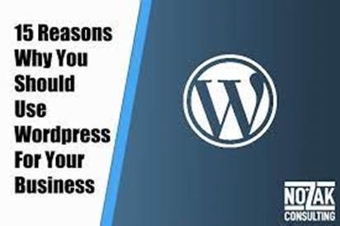

· Easy to Use

· Free!

· Ownership

· Flexible with Themes and Plugins

· Getting Started in a very easy way

· Features

· Trust

· Do It Yourself

· Security

· SEO

· Sell Stuff Online

· Build Membership Sites

· Business Opportunities

· The WordPress Community

· Love Your Website

**WordPress Website in 5 Easy Steps:**

Here is a brief overview of the steps to take to get your WordPress website started.

· Pick a domain name.

· Choose a hosting provider & package.

· Install WordPress & choose your theme.

· Learn WordPress Dashboard & pick your WordPress plugins.

· Customize website.

**WordPress Development Services:**

**1.** **Custom WordPress Development:**

Open the WordPress and creating custom plugins and themes or used pre-built. First-class designers know the most recent patterns and offer other to use and construct from the beginning level and then integrate these plugins and themes into existing website to make world-class sites.

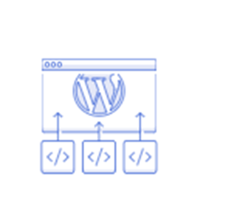

**2.** **Design and Front-end (Themes):**

Having an excellent plan could be a need among the competition for online clients and customers. Designers optimize UI and UX, whereas coordination your company's brand and vision into the website.



**3.** **WordPress Security:**

Guaranteeing the security and security of your site ought to continuously be the best priority. Security specialists can conduct code reviews and check vulnerabilities, working together with your group at any organization within the advancement process.



**4.** **Multisite:**

Use senior engineers to expertly arrange locales or blogs or work with them to get to other Multisite networks.



**5.** **Buddy Press:**

BuddyPress could be a suite of components that gives the usefulness to a common user for using social plateform. It permits notable addss, highlights and customizability, and it was built with a center on extensibility.



**6.** **WP Engine:**

WP Motor gives overseen WordPress facilitating, capturing 5% of all online activity on the destinations it hosts. Using WP Motor can provide improved security, quicker reaction times, and less downtime.



**5 Web Development Blogs You Should Be Reading:**

**1.** **Developer Drive:**

It is your choice that if you're fair starting your career in web development.Web engineers, web developers, coder offers the most recent news within the World of web improvement. This includes opinion articles, instructional exercises, tips & tricks to begin off on the proper foot. Are you looking to memorize how to play with coding? How approximately guaranteeing your location is secure and straightforward for customers to explore? Or would you like to keep tabs on each Microsoft program discharge? From JavaScript to versatile advancement,all things are covered in this plateform.

**2.** **CodeNewbie:**

If you're a code newbie seeking out an best place of all these things related to web advancement, you're within the correct place.CodeNewbie offers to hear the stories of web designers and serves as a volunteer for individuals to pursue career counsel, whereas hearing stories from individuals on their coding travel through the site's podcasts.

**3.** **Scotch.io:**

This web journal is full of instructional exercises on everything from JavaScript to PHP. They, too, offer a few curiously courses that require little commitment and can offer assistance take your coding skill to the following level.

**4.** **Simple Programmer:**

This web journal provide a well detailed description about about that how to make web engineer. If you've pondered almost something web improvement-related, there's a great chance they've composed approximatelyabout that. Essential Software engineer puts his efforts on write place, keeping touched with you with some humor whereas giving you a good ideas. They're continually posting modern articles – nearly day by day – so you'll never be bored.

**5.** **Codrops:**

Codrops is a web plan and advancement web journal provided valuable tutorials and articles on the latest trends within the industry to their customers. Codrops distributes test recordings that focus on modern thoughts and motivation for tackling issues and handling challenges around web improvement. Take a look, and you will get new ideas on how to create a new skillset!

**Conclusion:**

WordPress is a web-building plateform and considered as one of the foremost widespread and widely utilized CMS within the World. The reason for its popularity is the astounding highlights and traits that are available and provided by the platform of wordpress.WordPress is a web distributing program you'll utilize to make an excellent site or web journal. It may be the most straightforward and most adaptable blogging and Content Management System (CMS) for beginners.